AWS INTERNSHIP PROJECT

SUBMITTED BY :
- NAME: KADALI BALA NAGENDRA
EMAIL ID: balub4016@gmail.com
Regd.no: 23221A0547
College: BVC engineering college
- NAME: REDDY RUPESH
EMAIL ID: reddyrupesh117@gmail.com
Regd.no : 323506402449
College : ANDHRA UNIVERSITY COLLEGE OF ENGINEERING
- NAME: Rapaka praveen surya krishna
EMAIL ID: jogasyamala2@gmail.com
Regd.no: 23551A42A6
College: Godavari institute of engineering technology
- NAME: Lakshmi Ravi Krishna
EMAIL ID: srinivasgalla222@gmail.com
Regd.no: 24BQ1A5473
College: VVIT
Mentors: Mr Jutthuka Lovababu
Mr Juttuka Lovababu
Platform: skills AP APSSDC
Contents
- Abstract
- AWS Services Used
- Procedure
- Results and Screenshots
- Conclusion
ABSTRACT:
The Restaurant Management System is a cloud-based web application hosted on Amazon EC2 using the Apache HTTP Server. This project demonstrates how a restaurant website can be deployed on AWS cloud infrastructure. The application provides information about the restaurant, menu, food items, services, and contact details through a responsive web interface. This project offers practical experience in Linux server management, Apache web hosting, network configuration, and cloud deployment using AWS.
SERVICES:
1. Virtual Private Cloud (VPC)
Amazon Virtual Private Cloud (Amazon VPC) provides a secure and isolated virtual networking environment for AWS resources. It allows users to create their own private network, configure IP address ranges, create subnets, associate security groups, and configure route tables. In this project, the VPC is used to securely host the Restaurant Management System on Amazon EC2.
2. Amazon Elastic Compute Cloud (EC2)
Amazon Elastic Compute Cloud (Amazon EC2) is a web service that provides secure, scalable, and resizable virtual servers in the cloud. It enables users to launch Linux or Windows instances, install software, and host web applications. In this project, an Amazon Linux 2023 EC2 instance is used to install the Apache HTTP Server and host the Restaurant Management System website.
3. Security Groups
A Security Group acts as a virtual firewall for an EC2 instance. It controls inbound and outbound traffic by allowing or denying specific network ports. In this project, SSH (Port 22), HTTP (Port 80), and HTTPS (Port 443) are enabled to allow secure remote access and web access to the Restaurant Management System.
4. Apache HTTP Server (httpd)
Apache HTTP Server is an open-source web server used to host websites and web applications. It serves HTML, CSS, and JavaScript files to users through a web browser. In this project, Apache is installed on the Amazon EC2 instance to host the Restaurant Management System website and make it accessible over the internet.

PROCEDURE:

1. VPC CREATION
• First, create a VPC (restaurant_vpc) in the AWS Management Console in the US East (N. Virginia) region with the IPv4 CIDR block 10.0.0.0/16.
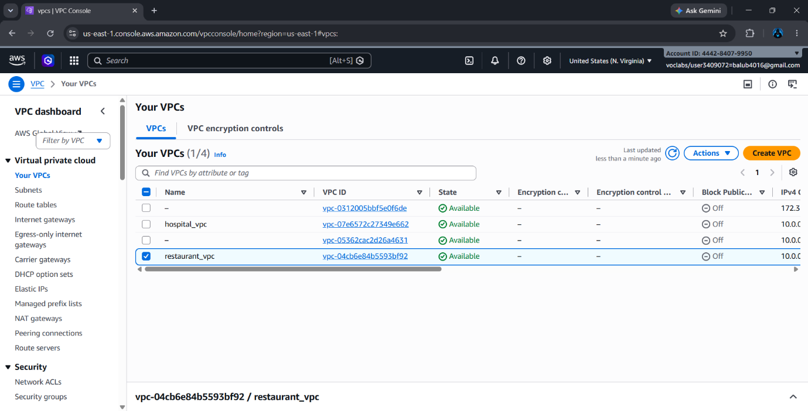

- Later create both public and private subnets for all three instances as shown.

Create one Public Subnet (Restaurant _public) and two Private Subnets (Restaurant_private1 and Restaurant _private2) to host the Restaurant Management System
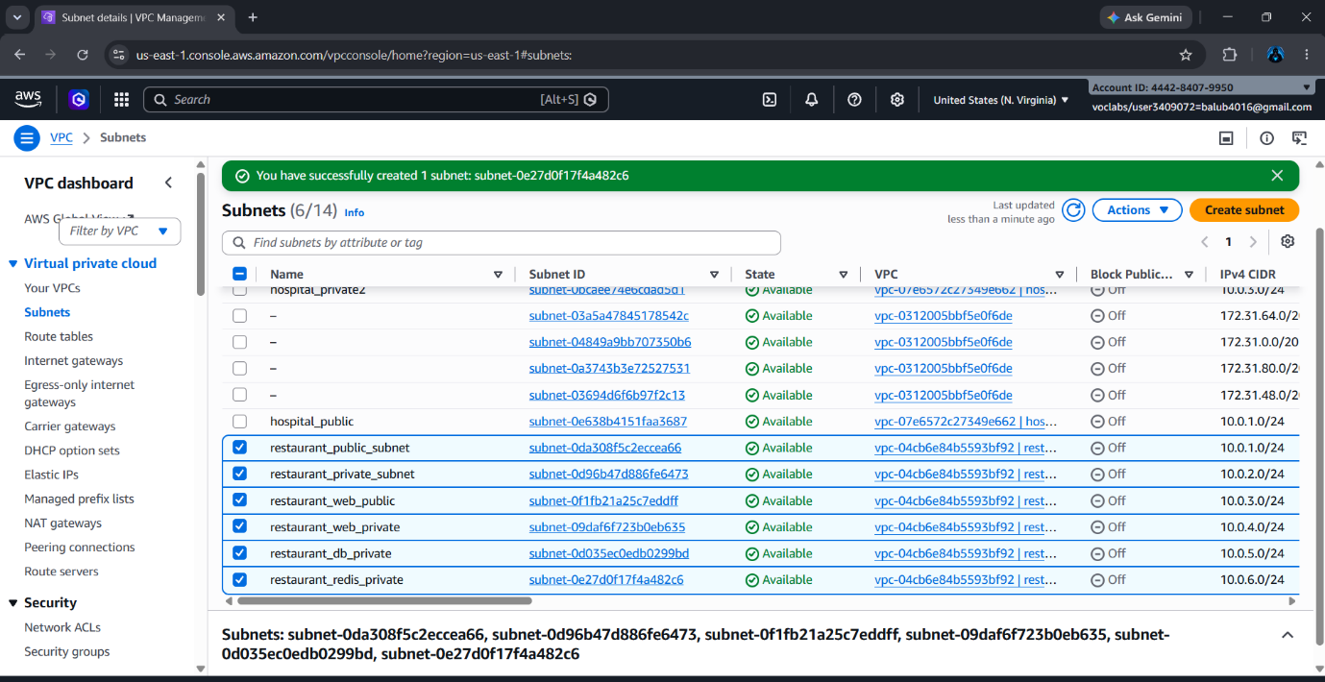
Create an Internet Gateway (Restaurant _igw) and attach it to the Restaurant _vpc.

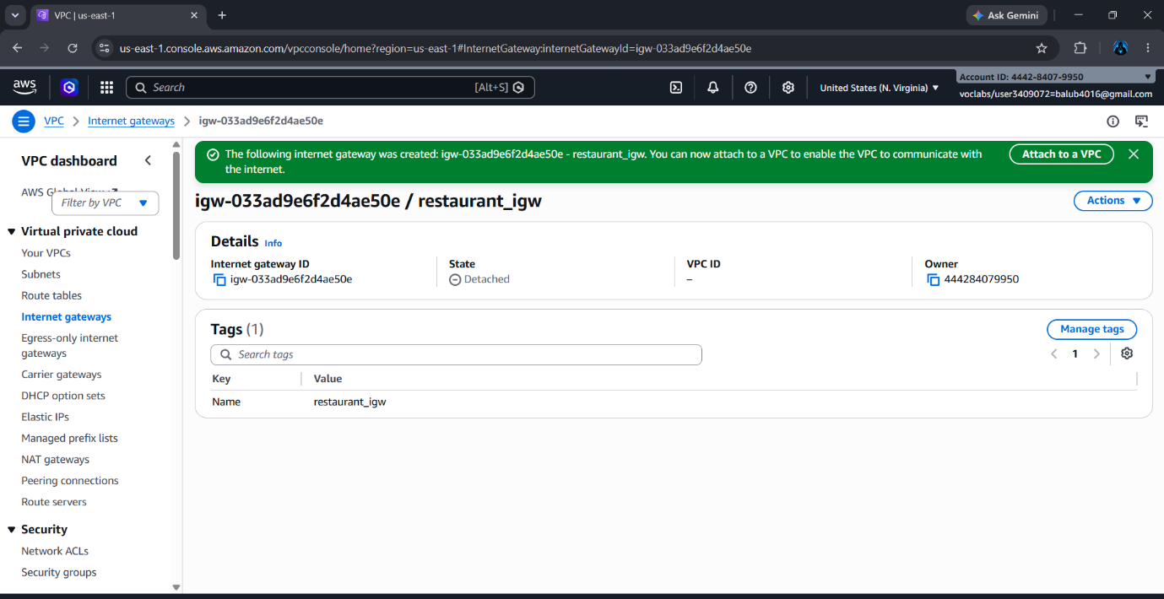

Create route tables for public and private internet gateways (project_rt_private, project_rt_public)
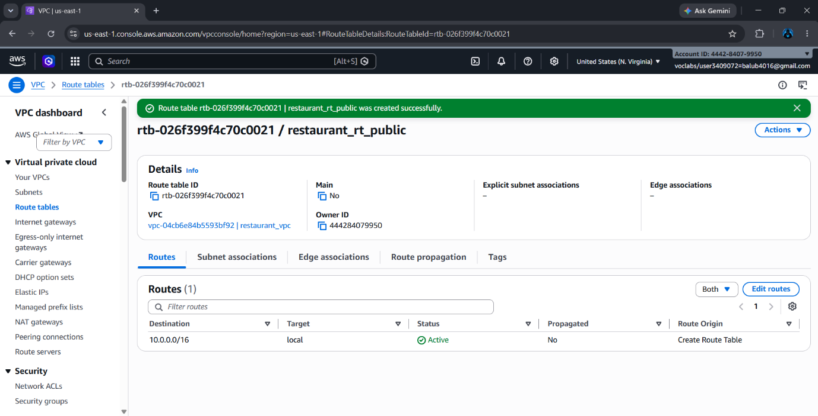
Create route tables (restaurant_public_rt and restaurant_private_rt) and associate them with the public and private subnets.
2. EC2 Instance Creation:

Now create three EC2 instances in the EC2 service (restaurant_web_server, restaurant_db_server, and restaurant_redis_server). Amazon EC2 (Elastic Compute Cloud) provides secure and scalable virtual servers to deploy and host applications in the AWS Cloud.
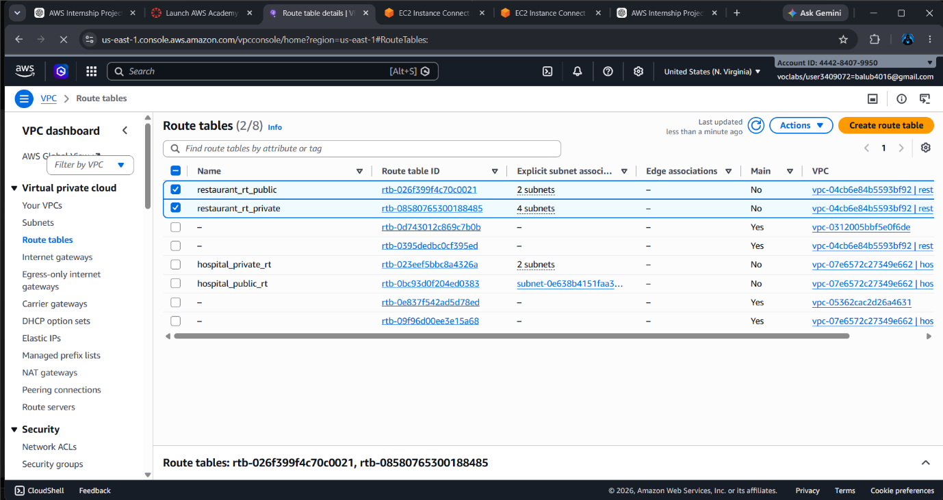

Start by choosing the Amazon Linux 2023 AMI (Amazon Machine Image), select the t3.micro (Free Tier Eligible) instance type, choose the US East (N. Virginia) region, select the restaurant_vpc and the required subnet, configure 8 GB gp3 storage, and add a unique Name Tag for each instance (restaurant_web_server, restaurant_db_server, and restaurant_redis_server).
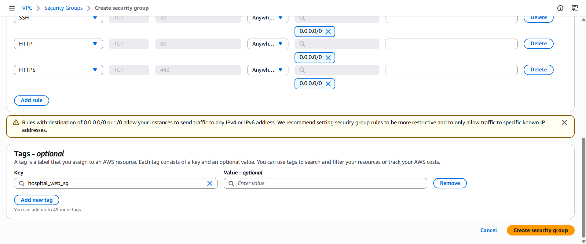

After adding the tags, create and configure a Security Group (restaurant_sg). Add the required inbound rules to allow SSH (Port 22), HTTP (Port 80), and HTTPS (Port 443) access to the web server
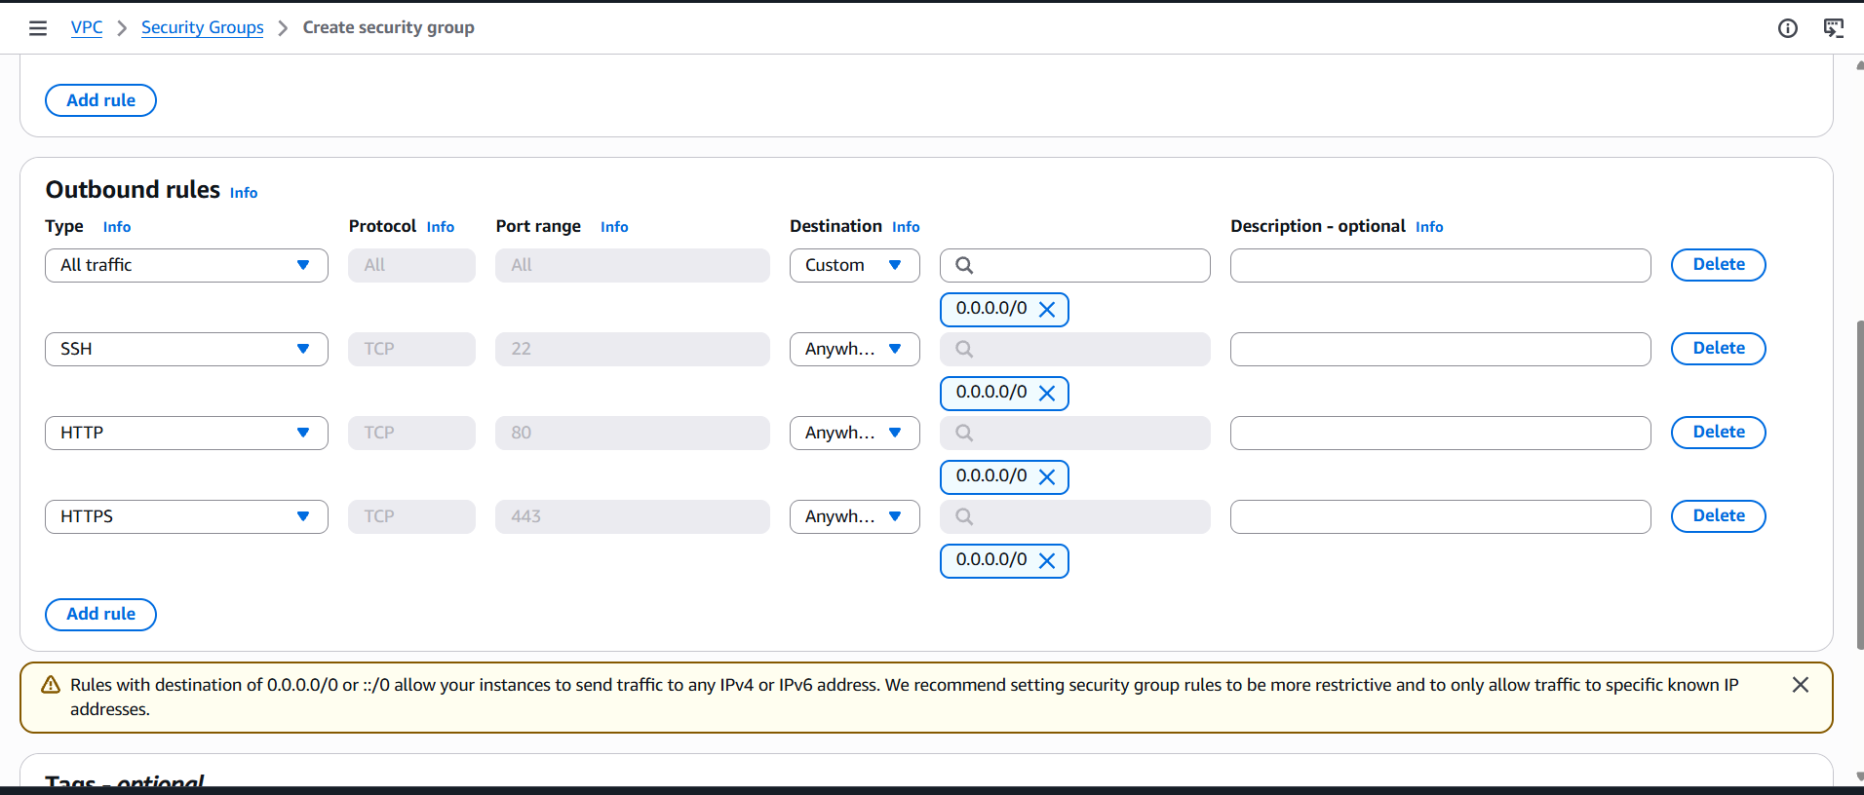

● Finally, create a new key pair and download the .pem key file. In this project, we used an RSA key pair with the name Restaurant_key. The downloaded key pair is used to securely connect to the EC2 instances. After downloading the key pair, launch the instance successfully.

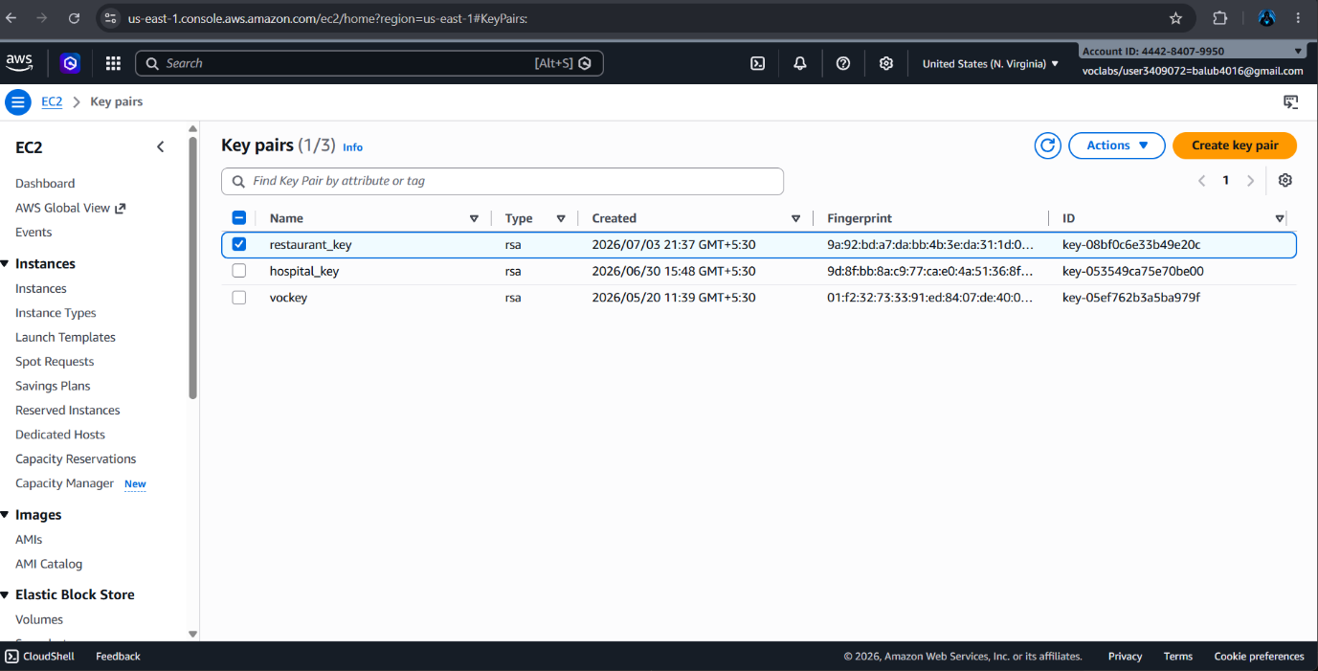

● In the same way, create all the required EC2 instances for the Restaurant Management System project:
- Restaurant_web_server
- Restaurant _db_server
- Restaurant _redis_server
After launching, verify that all the instances are in the Running state.
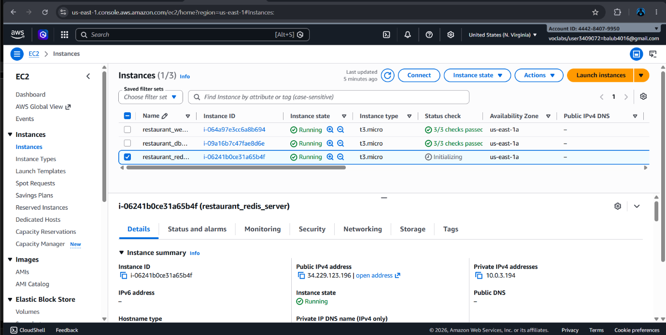
●After launching the EC2 instance, connect to the restaurant_web_server using EC2 Instance Connect from the AWS Management Console.

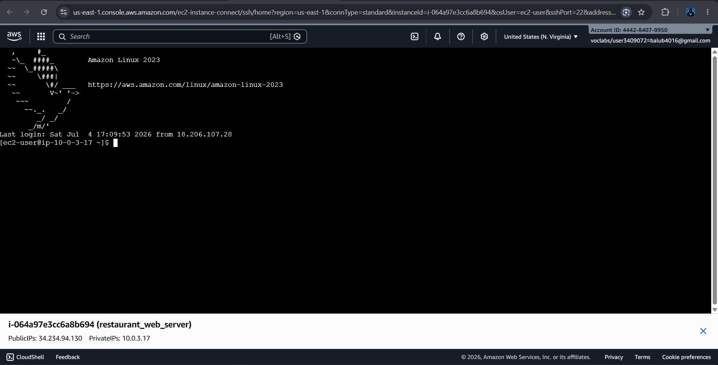

● After successfully connecting to the EC2 instance, update the system packages and install the Apache HTTP Server using the following commands:
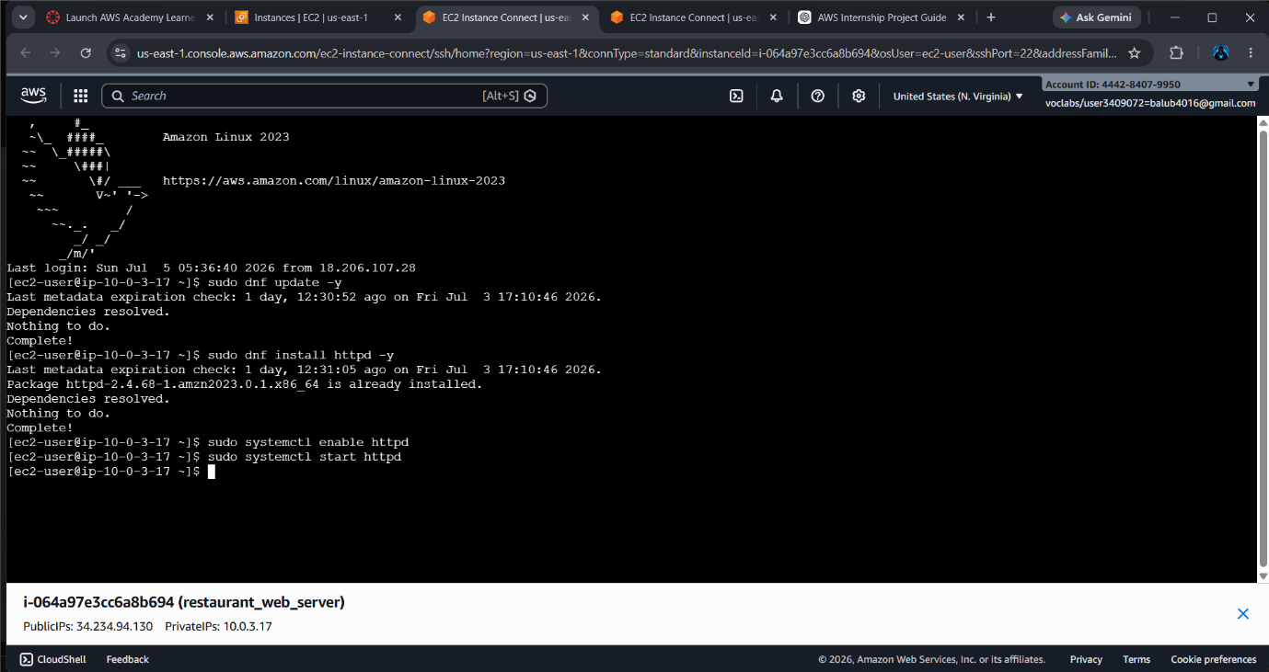

● After installing Apache, start the web server, enable it to start automatically after reboot, and verify its status using the following commands:

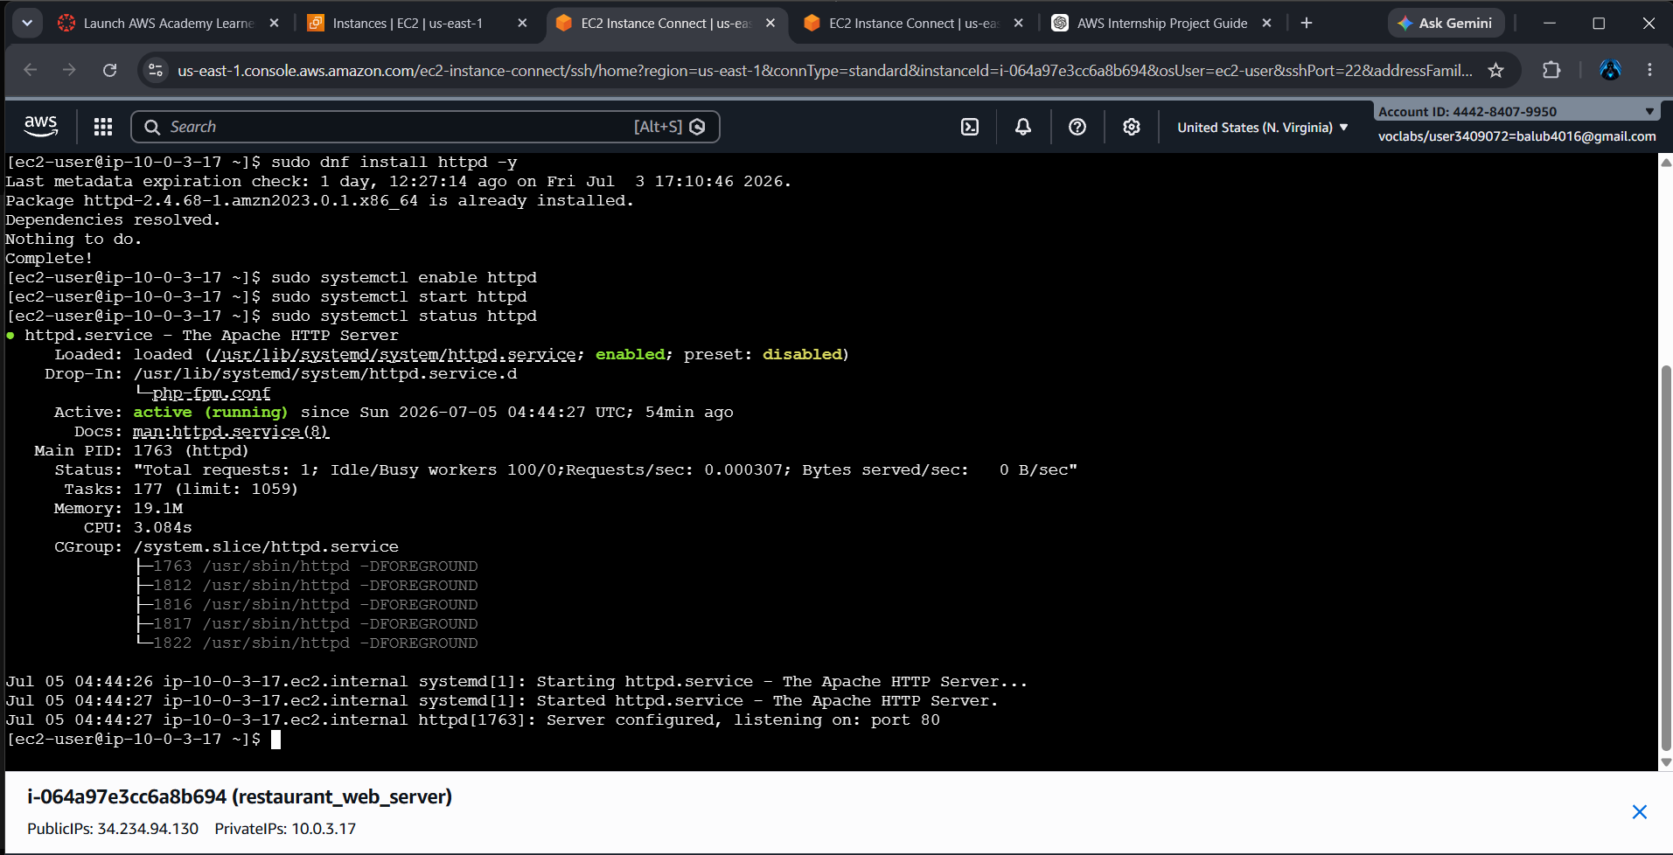

● After starting the Apache service, open the Public IPv4 Address of the restaurant_web_server instance in a web browser.
● If the installation is successful, the default Apache web page displaying "It works!" appears, confirming that the web server is accessible over the internet.

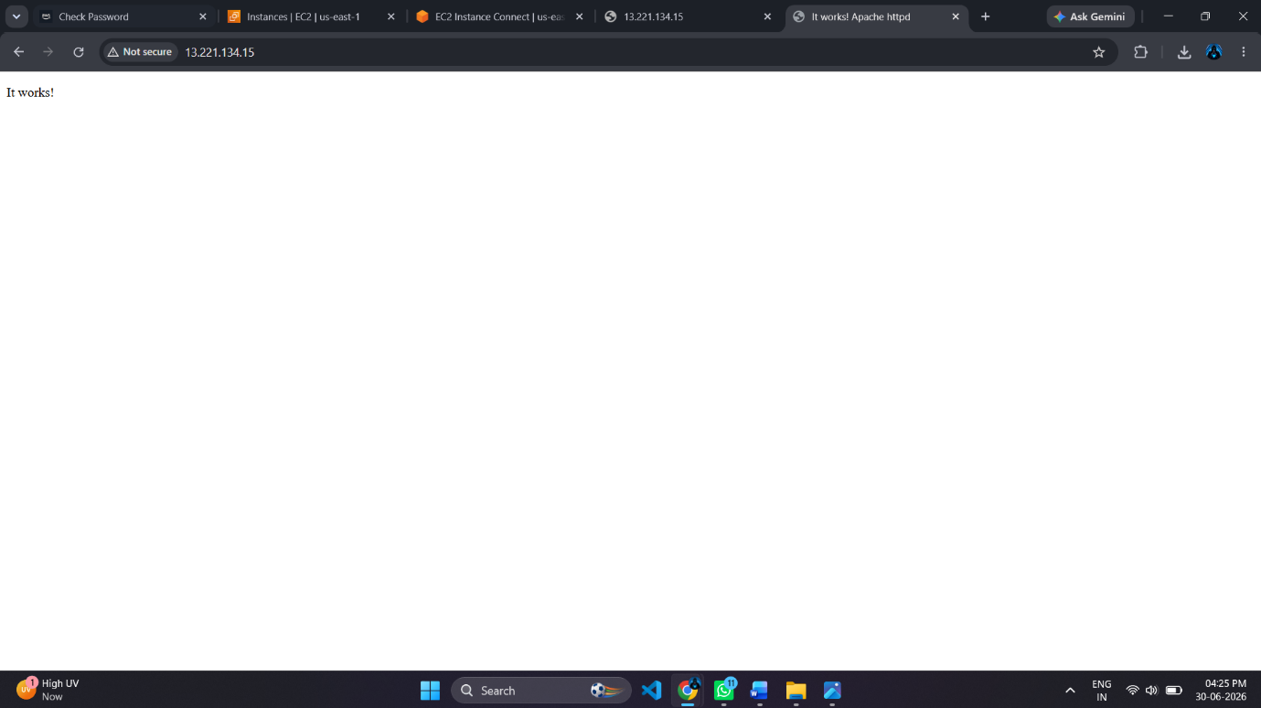

● After verifying the Apache Web Server, navigate to the Apache web root directory and open the default index.html file using the Nano text editor.
● Replace the default HTML content with the Restaurant Management System web page code and save the file.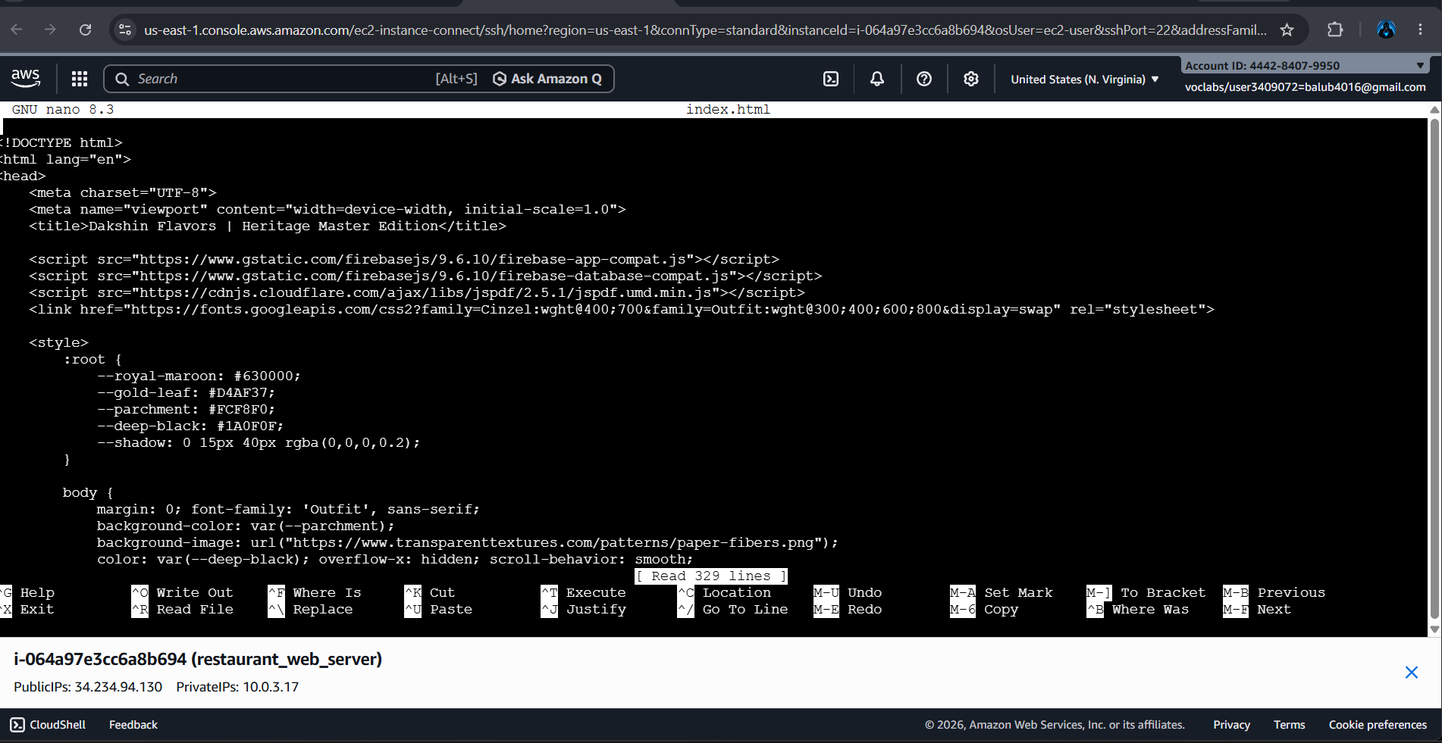

• After replacing the default Apache web page with the Restaurant Management System HTML code, save the index.html file and restart the Apache HTTP Server to apply the changes.
• Open the Public IPv4 Address of the restaurant_web_server instance in a web browser. If the deployment is successful, the Restaurant Management System home page is displayed, confirming that the website has been successfully hosted on the AWS EC2 instance and is accessible over the internet.

• After successfully hosting the Restaurant Management System on the Apache Web Server, the application login page is displayed, confirming that the website has been deployed correctly on the AWS EC2 instance.

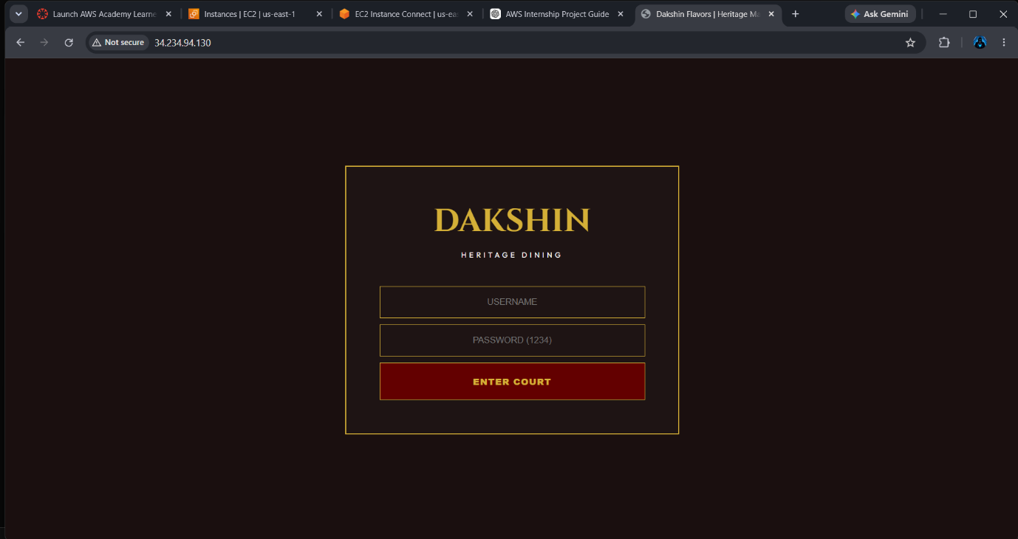
• After logging into the application, the Restaurant Management System home page is displayed successfully. This verifies that the website is running properly and is accessible through the Public IPv4 Address of the EC2 instance.

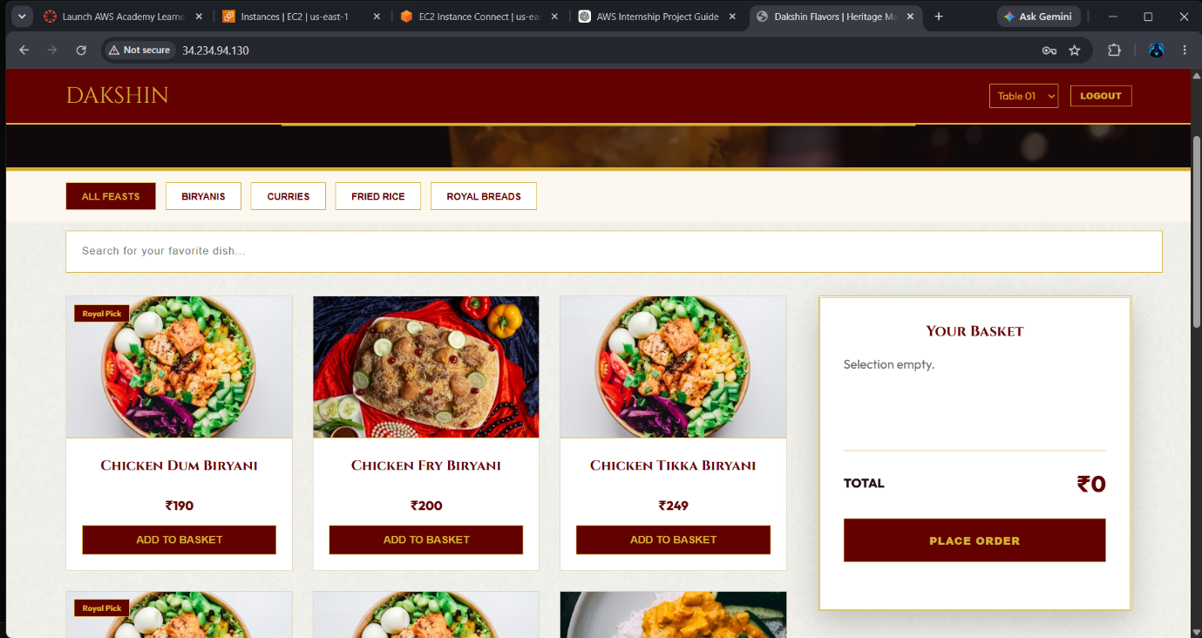
Reference Links
- Apache HTTP Server Installation:
https://httpd.apache.org/docs/
- Amazon EC2 Documentation:
https://docs.aws.amazon.com/ec2/
- Amazon VPC Documentation:
https://docs.aws.amazon.com/vpc/
- MariaDB Installation Guide:
https://mariadb.org/documentation/
- Redis Installation Guide:
https://redis.io/docs/
- Amazon Linux 2023 Documentation:
https://docs.aws.amazon.com/linux/
Final Website Link: http://44.210.193.62

